**Permafrost RCN Protocol 2 Forcing Procedure**

Author: David Lawrence (dlawren@ucar.edu)

**Forcing datasets provided**

The forcing dataset for the Permafrost RCN Protocol 2 future projections is provided as monthly anomaly timeseries for all the state variables and ratio timeseries for all the flux variables. The monthly anomalies/ratios are calculated from CCSM4 simulations that were contributed to CMIP5. Note that anomaly/ratio timeseries from other climate model projections could be similarly calculated and used. For Protocol 2, we would strongly prefer if all groups use the anomaly/ratio data provided so that we can focus on the model response. Future experiments with alternative climate model projections could examine projection uncertainty.

Anomaly/scale factor forcing datasets are provided through the Earth System Grid (<http://www.earthsystemgrid.org/dataset/ucar.cgd.ccsm4.permafrostRCN_protocol2_forcing.html>) for RCP8.5 and RCP4.5:

RCP8.5 2005 to 2300 (CCSM4 case names b40.rcp8_5.1deg.001 and b40.rcp8_5.2300.001)

RCP4.5 2005 to 2300 (CCSM4 case names b40.rcp4_5.1deg.001 and b40.rcp4_5.2300.001)

The base climatological period which is used to calculate the monthly anomalies/scale factors is 1996-2015 (from CCSM4 historical simulation case name b40.20th.track1.1deg.008 and the relevant future RCP simulation from above). Note that a 20-yr period that straddles 2006, the starting year of the anomaly/scale factor forcing dataset, is used to minimize large anomalies in the first few years of the anomaly/scale factor datasets.

The state land forcing anomaly variables provided include (CMIP5 variable naming convention in parentheses) -

TBOT (tas) - reference height surface air temperature (K)

QBOT (huss) – reference height specific humidity (kg/kg)

UBOT (uas) – lowest atmospheric level zonal wind speed (m/s)

VBOT (vas) – lowest atmospheric level meridional wind speed (m/s)

PSRF (ps) – Surface pressure (Pa)

The flux land forcing scale factor variables provided include -

P (pr) - precipitation (total precip, assuming that land model determines if rain or snow)

SW (rsds) – downwelling solar radiation at surface

LW (rlds) – downwelling longwave radiation at surface

For the state variables, the monthly timeseries will represent absolute anomalies calculated, for example for temperature from CCSM4 as:



where m is the month and y is the year from 2005 to 2300 and y1=1985 and y2=2004.

For the flux variables, the monthly timeseries is calculated as scale factors relative to the base period, for example for precipitation:



See Figure 1 below that shows the Arctic area and annual mean time series of the anomaly/scale factor for each variable.

**Recommended method to apply the anomaly for state variables**

For state variables the forcing variable should be modified from the observational dataset according to the following equations:











where *TBOT(t,m,y)* is the forcing temperature that is used by the land model at timestep *t,* month *m*, and year *y*. *TBOTobs(t,m,yobs)* is the obs temperature at time *t,m,yobs* where *yobs* is the year of the historic observational timeseries (we recommend that groups loop over the last 10 years of the historical observed forcing data to represent some interannual variability, so *yobs* would loop over 1996-2005). *∆TBOT(m,y)* is the monthly anomaly for month *m* and year *y* calculated from the CCSM4 simulations.

Note that for QBOT a check that the updated variable is greater than zero is required.

**Recommended method to apply the scale factor for flux variables**

For flux variables the forcing variable should be modified relative to the observational forcing dataset value according to the following equations:







As with the state variables, *yobs* would loop over a 10-year period from the observed historical forcing data to represent interannual variability (1996-2005).

**Regridding**

Data are provided at the CCSM4 resolution (0.9olat x 1.25olon) and will need to be regridded by each modeling group to their target resolution. Gridcell area, landmask and landfrac variables are also included.

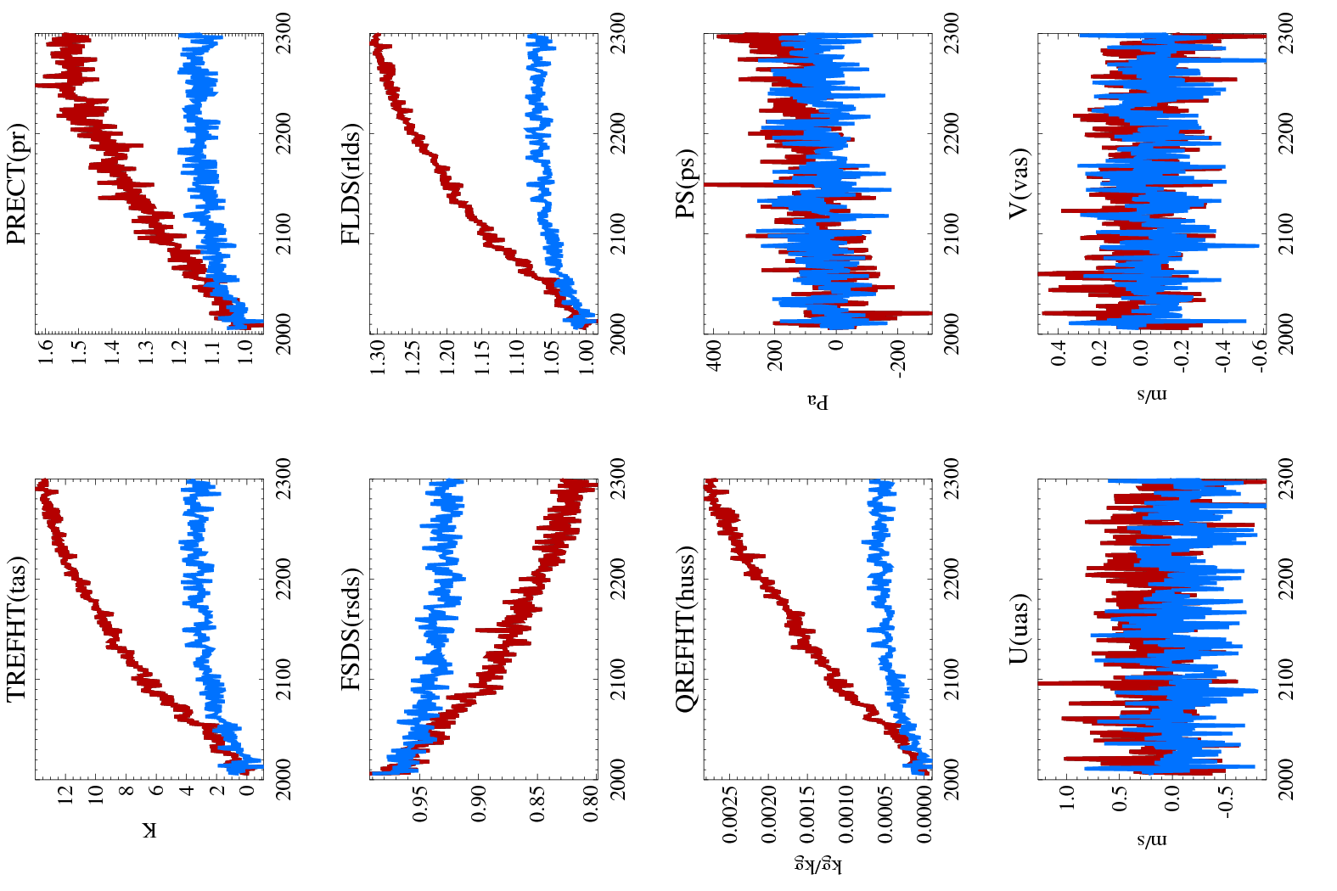Figure 1: Annual mean time series of anomaly/scale factors averaged over all land >50oN. RCP8.5 (red); RCP4.5 (blue).

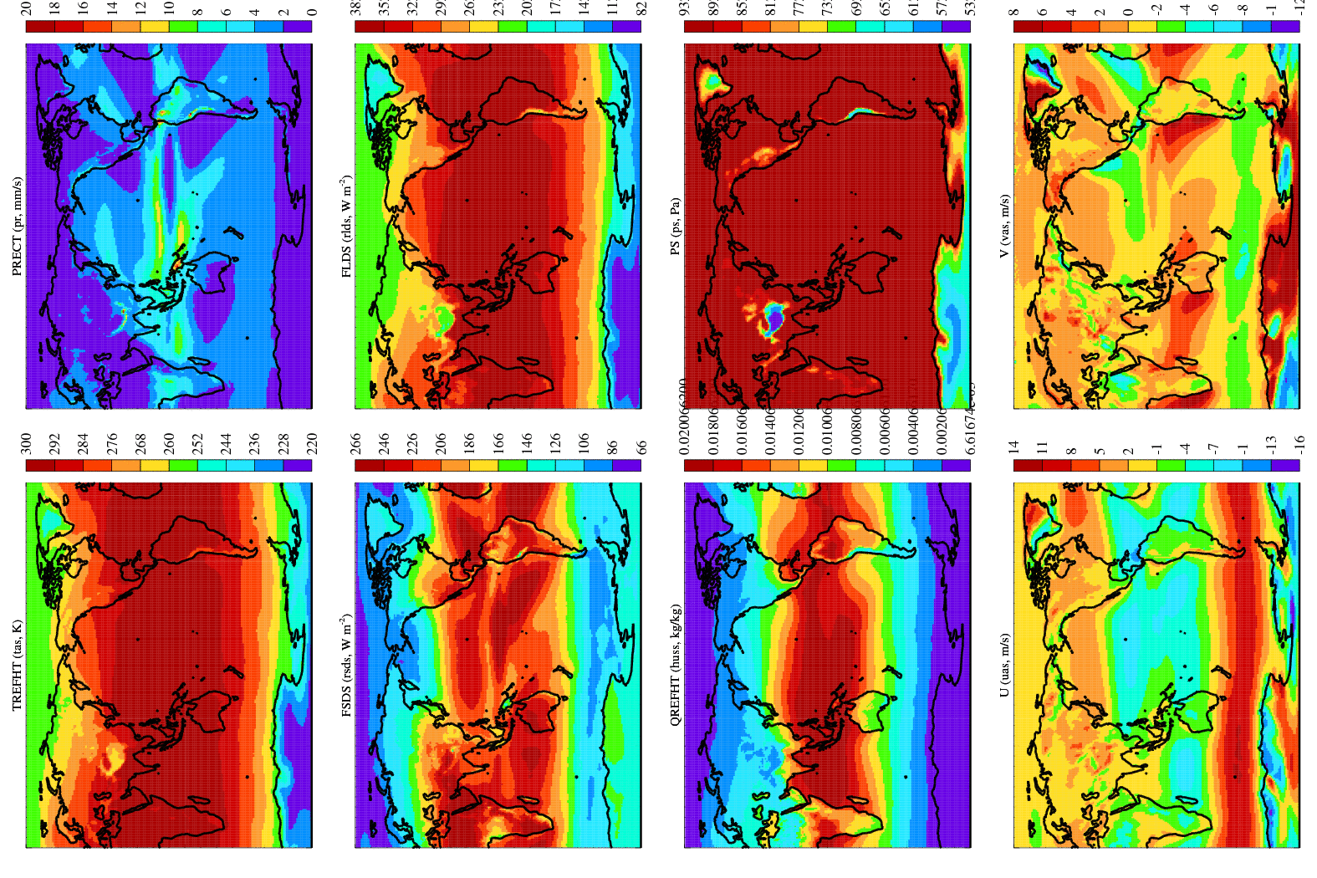

Figure 2: Climatological maps of output from CCSM4 for the 1996-2015 base period.